***Led light alarm clock***

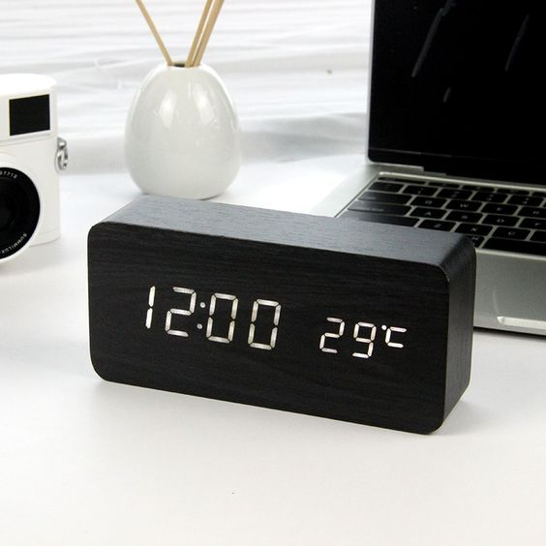

*The LED alarm clock is made of plastic material. The watch has many functions: date and time, alarm, temperature, date memory, ... Especially comes with a pen that can write on notes or messages you want to send. This is a meaningful gift for your girlfriend, or as a birthday gift, a gift for friends*